There are two txt files, input.txt should be empty. Crackme.txt is file we need to crack.

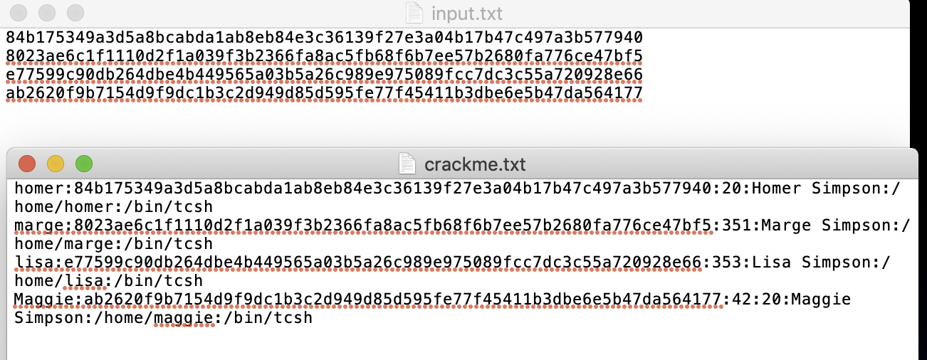

Then I run the part of my code as below. I read “crackme.txt” and use for loop to read each line and split each by “:”, then put each part into a list, call “au”. The list should look like

[“homer”, “84b1………….7940”, “20”, “Homer”, “Simpson”, “home”, “homer”, “bin”, “tcsh”]

Then I only write au[1] to “input.txt”.

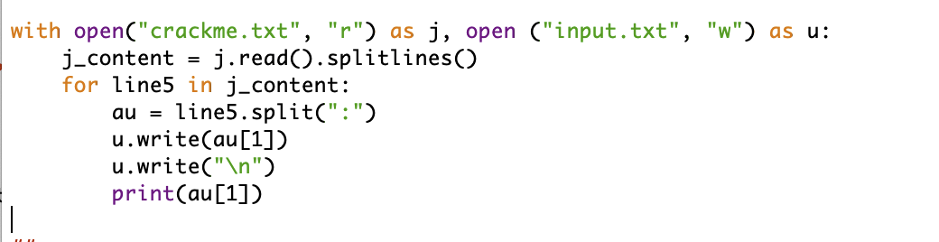

When I run the code, it writes what I want into “input.txt” and also can be print out. But it gives me the index error: list index out of range.

